Date: Monday, May 6, 2019

Subject: Language Arts

Topic: Types of Adverbs/Word Building

Sub-topics: Adverb of Manner, Time and Place/Using a Thesaurus

Time: 1 hour 30 minutes (8:45 - 10:15 a.m.)

Materials: passage, concept chart on adverbs and thesaurus, flashcards, markers, worksheet

References:
- (n.d) Retrieved from https://www.gingersoftware.com/content/grammar-rules/adverb/
- (n.d) Retrieved from https://www.englishgrammar.org/adverbs-worksheet-4/
- Language Tree Student’s Book 5 pgs. 131, 140-141

Previous Knowledge: Students can identify adverbs as who, when, where or how often.

Strands | Content Standards | Learning Outcomes
Reading | CS25 – Read aloud | 25.21 When reading aloud, pronounce most commonly occurring, regularly and irregularly spelt words, accurately and fluently.
Reading | CS25 – Read aloud | 25.22 Read with fluency and confidence from a variety of prose, poetry and non-fiction texts, including texts seen for the first time.
Speaking | CS19 – Use Speech Prosody and Gesture | 19.7 Pace the delivery of speech appropriately for the listener and the situation.
Writing | CS41 – Spelling Words Appropriately | 41.9 Spell an increasing range of irregularly spelt words correctly.
Speaking | CS9 – Express Opinions and Communicate Ideas | 9.11 Use a range of adjectives and adverbs when expressing ideas.

Objectives: Using the passage “The Stray Dog,” and given the definitions for adverbs and thesaurus, students will be able to:
- Define what a thesaurus is.
- Explain the use of thesaurus.
- Use a thesaurus effectively.
- Differentiate between adverbs of manner, time and place.
- List examples of adverbs of manner, time and place.
- Identify the adverbs in the passage and say whether its adverb of manner, time or place.

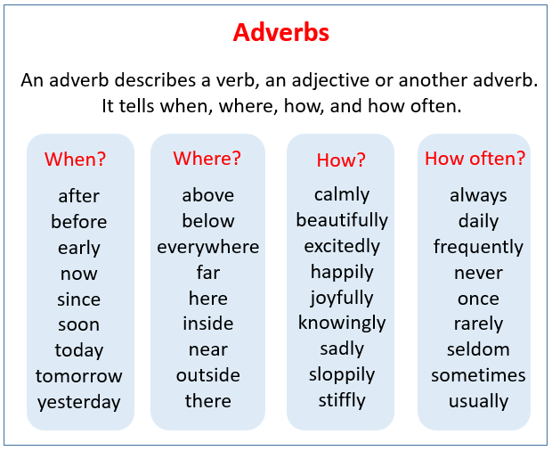
Concepts: Types of Adverbs
Adverbs of Manner
An adverb of manner will explain how an action is carried out. Very often adverbs of manner are adjectives with –ly added to the end, but this is certainly not always the case. In fact, some adverbs of manner will have the same spelling as the adjective form.

Some examples of adverbs of manner include: Slowly, rapidly, clumsily, badly, diligently, sweetly, warmly, sadly

Adverb of manner examples:
-She passed the exam easily.
-They walk quickly to catch the train.
-The dinner party went badly.
-John answered the question correctly.

Adverbs of Place
An adverb of place, sometimes called spatial adverbs, will help explain where an action happens. Adverbs of place will be associated with the action of the verb in a sentence, providing context for direction, distance and position: southeast, everywhere, up, left, close by, back, inside, around. These terms don’t usually end in –ly.

Adverbs of place examples:
Directions
-New York is located north of Philadelphia.
-They travelled down the mountainside.
-First, I looked here, and then I looked there, but I can’t find them anywhere.

Distance
-There was a deli.
-Jane is moving far away.
-Carly is sitting close to me.

Position
-The treasure lies underneath the box.
-The cat is sleeping on the bed.
-Why are you standing in the middle of the dancefloor?

In addition, some adverbs of position will refer to a direction of movement. These often end in –ward or –wards.

-Oscar travelled onward to Los Angeles.
-Hannah looked upwards to the heavens.
-Molly, move forward to the front of the queue, please.

Adverbs of Time
Adverbs of time, while seemingly similar to adverbs of frequency, tell us when something happens. Adverbs of time are usually placed at the end of a sentence.

Adverbs of time examples:
-I will see you.
-Harvey forgot his lunch yesterday and again today.
-I have to go now.
-We first met Julie last year.

While it’s almost always correct to have the adverb of time at the end of the sentence, you can place it at the start of the sentence to put a different emphasis on the time if it is important to the context.

- -Last year was the worst year of my life.
- -Tomorrow our fate will be sealed.
- -Yesterday my troubles seemed so far away

Skills: read passage, differentiate between adverbs and write sentences with adverbs

Attitude: Appreciation for reading, willing participate and respect other’s opinion

Linkage: Science (Living and Non-living things) and Expressive Art (Poster)

Introduction:
- Engage students in the adverb detective game.
- Present students with flash cards that have different adverbs.
- Place a chart on the board that labelled: when, how, where and how often.
- Have students place their card under the correct column. Discuss students’ answers.

Development: Discussion and Guided Discovery Approaches
- Elicit from students the definition of adverb. Have students read the definition of adverb.
- Students will read a short passage. Then identify as many adverbs as possible within the time allotted to them. Remind students that an adverb answers the questions How? Where? When? or How often?
- Discuss students’ list of adverbs found in the passage.
- Tell students that today will be looking at the different types of adverbs.
- Elicit from students if they know of any. After listening to students’ responses a video will be play on the three types of adverbs that will be discussed.
- Elicit from students what they learnt from the video watched.
- Direct students to page 140 in their language tree text book, where they will read the information on adverb of time, place and manner.
- Elicit from students the type of adverbs they have being introduce to and what question each one answer. Provide examples of adverbs for manner, time and place.
- Students will identify the adverb in sentences orally and say what type it is.
- Present a thesaurus to students. Elicit from them what is a thesaurus and why it is being used. How does a thesaurus help them?
- After listening to students’ responses, explain the importance of a thesaurus.
- Review what synonyms and antonyms are with examples.
- Demonstrate to students how to use a thesaurus. Ask students to turn to page 131 in the Language Tree Students Bk 4. Have students read the two extracts from the thesaurus, helping students to see the variations in meaning that exist among the words.
- Explain to students that they will use words from the extracts to replace two given words in a passage.
- Place students into groups of four. Provide each group with markers and a news print. Students will do Ex 1 in writing. Select groups randomly to read their new paragraph.
- Select groups to share their stories.

Closure: Allow students to share what they learn about adverbs and thesaurus.

Conclusion:
- Group 1 and 2 students will complete an activity sheet on adverbs of time, manner and place.
- Group 3 and 4 students will complete an activity on the using a thesaurus.
- Check student’s answers.

Extended Activity:
- Students will write a story with different adverbs of time, manner and place.

Lesson Reflection:
______________________________________________________________________________________________________________________________________________________________________________________________________________________________________________________________________________________________________________________________________________________________________________________________________________________________________________________________________________________________________________________________________________________________________________________________________________________________________________________________________________________________________________________________________________________________________________________________________________________________________________________________________________________________________________________________________________________________________________________________________________________________________________________

