Books To help PREPARe SIBLINGS BEFORE YOU GO INTO LABOR
SEPTEMBER 3, 2012 • https://growingbookbybook.com/
It’s Labor Day and we know that moms have the toughest job! I thought we’d look at some books to read with siblings before you go into labor with that new baby. There has been a baby boy explosion this year in my life- Nathan, Bryce, Connor, Eli, Zachary and Benjamin. All of these boys have joined the families of people that I know.
Let’s explore some books that can be read in preparation for a new little one joining the household.
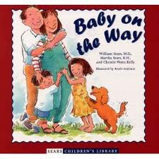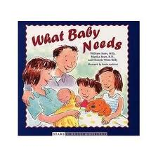
Baby on the Way by Sears and Watts Kelly compares how a mother feels during a pregnancy with experiences that a child can relate to in their own lives. What Baby Needs by the same authors looks at how family life changes when a new infant enters the house. These books would work well for ages 2-8.
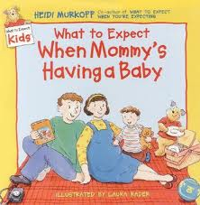
What to Expect When Mommy’s Having a Baby by Murkoff takes you through that list of questions like, How are babies made? and How does the baby grow? You may know Murkoff from her adult book, What to Expect When You are Expecting. This one would probably be best for ages 3-8.
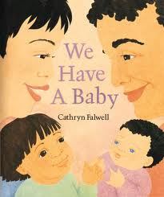
We Have a Baby by Falwell is a very simple but beautiful picture book depicting a baby arriving home and all the routines that go along with having a new baby in the house. This book would work especially well with very littles ones 18 months-4 years.
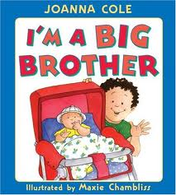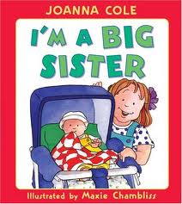
I’m a Big Brother and I’m a Big Sister by Cole are identical books except for the gender differences. Written in first person, the text makes it easy for older siblings to connect with what it’s like to have a new baby in the house. Age recommendation would be 3-8 years old.
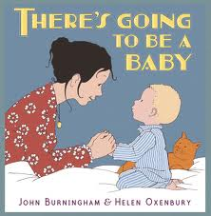
There’s Going to Be a Baby by Burningham looks at all the questions a little one might have about a new little one. The boy in the story thinks about what it might be like to have a baby. He contemplates whether or not he may or may not like having the new addition to his family. This one would work well for ages 2-8.

