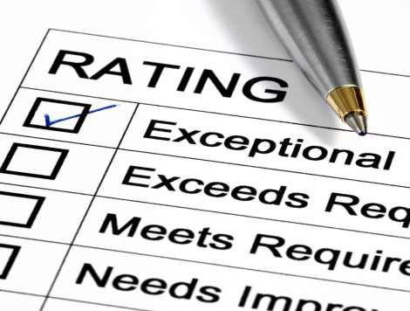

- Early Childhood Executive Director Performance Appraisal Form

Name:

Evaluation Period:

Title: Date:

PERFORMANCE PLANNING AND RESULTS

Performance Review

- Use a current job description (job descriptions are available on the HR web page).

- Rate the person's level of performance, using the definitions below.

- Review with employee each performance factor used to evaluate his/her work performance.

- Give an overall rating in the space provided, using the definitions below as a guide.

Performance Rating Definitions

The following ratings must be used to ensure commonality of language and consistency on overall ratings:
(There should be supporting comments to justify ratings of “Exceeds Expectations” or “Below Expectations”)

Exceeds Expectations Performance is routinely above job requirements Meets Expectations
Meets Expectations Performance is regularly competent and dependable
Below Expectations Performance fails to meet job requirements on a frequent basis
N/A I am unable to rate this aspect of the employee’s performance

- PERFORMANCE FACTORS (use job description as basis of this evaluation). Circle your rating for each item.

Administration - Measures effectiveness in planning, organizing and efficiently handling activities and eliminating unnecessary activities. | Exceeds Expectations  Meets Expectations  Below Expectations  N/A
Communication - Measures effectiveness in listening to others, expressing ideas, both orally and in writing and providing relevant and timely information to management, co-workers, subordinates, and families. | Exceeds Expectations  Meets Expectations  Below Expectations  N/A
Decision Making/Problem Solving - Measures effectiveness in understanding problems and making timely,  practical decisions as well as taking initiative and independent action within prescribed limits. | Exceeds Expectations  Meets Expectations  Below Expectations  N/A

Fiscal Management - Measures effectiveness in  establishing appropriate reporting and control procedures; operating efficiently at lowest cost; staying within established budgets. | Exceeds Expectations Meets Expectations Below Expectations  NA
Human Resource Management - Measures effectiveness in selecting qualified people; evaluating subordinates' performance; strengths and development needs; providing constructive feedback, and taking appropriate and timely action with marginal or unsatisfactory performers. Also considers efforts to further the CDN goal of equal employment opportunity. | Exceeds Expectations Meets Expectations Below Expectations  NA

Job Knowledge - Measures effectiveness in keeping knowledgeable of methods, techniques, and skills required in own job and related functions; remaining current on new developments affecting CDN and its work activities. | Exceeds Expectations  Meets Expectations  Below Expectations  N/A
Leadership - Measures effectiveness in accomplishing work assignments through subordinates; establishing  challenging goals; delegating and coordinating effectively; promoting innovation and team effort. | Exceeds Expectations  Meets Expectations  Below Expectations  N/A
Managing Change and Improvement - Measures effectiveness in initiating changes, adapting to necessary changes from old methods when they are no longer practical, identifying new methods and generating improvement in facility's performance. | Exceeds Expectations  Meets Expectations  Below Expectations  N/A
Responsiveness - Measures responsiveness and  courtesy in dealing with internal staff, families, and vendors; employee projects a courteous manner. | Exceeds Expectations  Meets Expectations  Below Expectations  N/A

Professionalism - Measures how well employee complies  with instructions and performs under unusual circumstances; consider record of attendance and punctuality. | Exceeds Expectations  Meets Expectations  Below Expectations  N/A
Facilities Management - Measures individual's work habits and attitudes as they apply to work safety. Consider their contribution to accident prevention, safety awareness, ability to care for CDN property and assurance that premises are clean, well-maintained, and safe. | Exceeds Expectations  Meets Expectations  Below Expectations  N/A

- EMPLOYEE STRENGTHS AND ACCOMPLISHMENTS: Include those which are relevant during this evaluation period. This should be related to performance or behavioral aspects you appreciated in their performance.

- PERFORMANCE AREAS WHICH NEED IMPROVEMENT:

- PLAN OF ACTION TOWARD IMPROVED PERFORMANCE:

- EMPLOYEE COMMENTS:

- JOB DESCRIPTION REVIEW SECTION: (Please check the appropriate box.)

  - Employee job description has been reviewed during this evaluation and no changes have been made to the job description at this time.

  - Employee job description has been reviewed during this evaluation and modifications have been proposed to the job description. The modified job description is attached to this evaluation.

- SIGNATURES:

Employee Date
(Signature does not necessarily denote agreement with official review and means only that the employee was given the opportunity to discuss the official review with the supervisor.)

Evaluated by Date

Reviewed by Date ____________________

