PROJECT

Sibling Kit

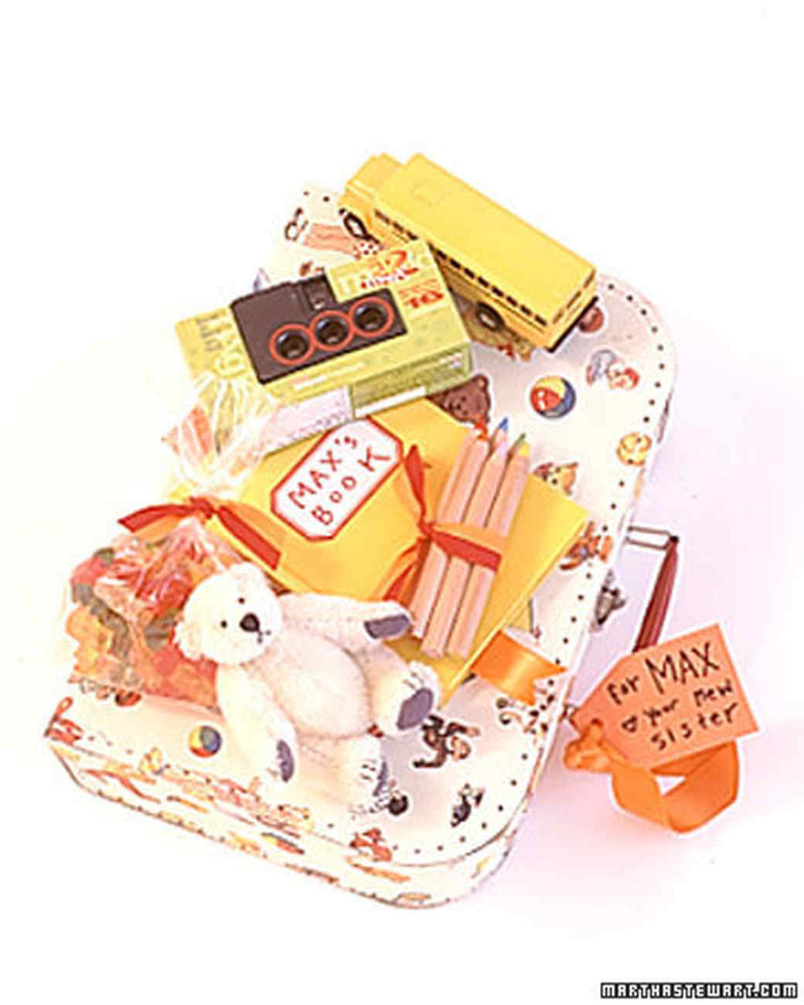

INTRODUCTION
When everybody at the hospital is paying attention only to the newborn, siblings can get bored or jealous. Surprise them with mini cardboard suitcases or folders filled with materials to keep them entertained. Include a couple of new toys, a small journal and colored pencils, a disposable camera, and a favorite snack. You might want to let the big kids know their gift is from their baby brother or sister.

