Date: Wednesday, March 20, 2019

Subject: Mathematics

Topic: Measurement

Sub-topic: Metric Unit of Capacity (Conversion)

Time: 1 hour (10:30 – 11:30 a.m.)

Materials: concept chart on conversion of metric unit of capacity, news print, markers, worksheet, notebook, pens, pencils

References:
- Addison-Wesley, pgs.
- (n.d) Retrieved from https://www.commoncoresheets.com/Math/Capacity/American %20Conversion%20capacity/English/1.pdf
- (n.d) Retrieved from https://study.com/academy/lesson/measuring-capacity-using-the-metric-system.html

Previous Knowledge: Students are can identify measure units of capacity and convert from unit to another.

Content Standard: CS 15 - Measure with care! (Measurement and Accuracy)

Learning Outcome:
15.19 Measure lengths, weights, volumes, time, temperature with metric and customary units and convert among them: select appropriate unit and instrument.

Objectives: Given the metric units of capacity and the rules to convert metric unit of capacity, students will be able to:
Explain that a liter is the basic metric unit of capacity.
List some things that are usually measured in liter.
Recite the metric unit of capacity table.
Convert metric units of capacity.

Concepts:
Metric Unit of Capacity
The metric units for capacity or volume include the milliliter and the liter. The milliliter is used to measure tiny or small amounts of liquid or fluid. Many times, when you get a prescription for some medicine that you need to drink, you will see the amount you need to take in milliliters. Liters are used to measure larger amounts of liquid. For example, you'll find liter bottles of soda and milk at the grocery store.

Both of these measurements for volume also have their own abbreviations. Milliliter is abbreviated with mL, and liter is abbreviated with L. For your prescriptions, you might see a written note that tells you to take 15 mL, 15 milliliters, twice a day. At the grocery store, you might see a jug of milk that contains 2 L, 2 liters. Notice that liter is abbreviated with a capital L instead of a lowercase l. This is to make sure that the L is L and not a number 1.

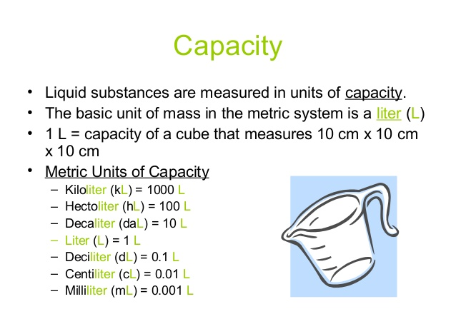
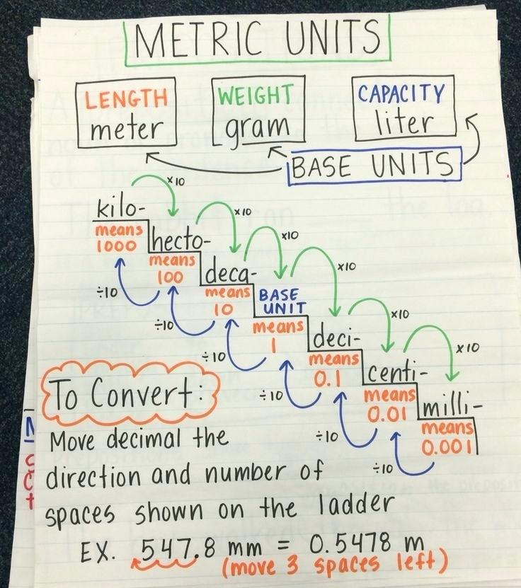

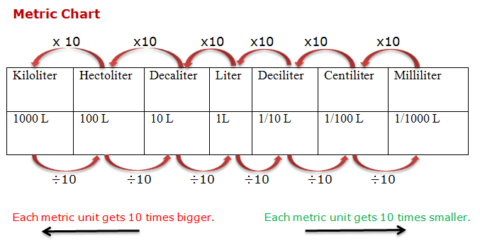
Skills: Estimate measurement unit and convert metric units of capacity.

Attitudes: Appreciation metric measurements and participation in group work

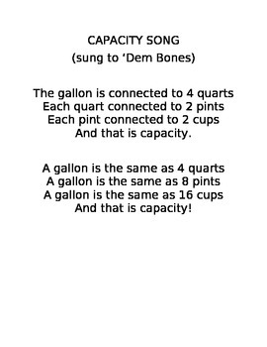
Linkages: Language (Read aloud) and Science (Investigating)

Introduction:
- Have students sing and dance to the conversion of capacity song.
- Review the table of conversion for customary units of capacity.
- Do two conversions within the customary unit of capacity measurements.

Development: Demonstration, Cooperative and Practice and Drill Approaches
- Discuss that things can be measured in smaller units, but it would take longer to measure them.
- Inform students that today we will focus on metric units of capacity.
- Explain to students that when dealing with metric unit of capacity we are going to be working with the liter family.
- Review the other families taught in previous class and when and why we would use them.
- Students will watch a video on metric unit of capacity.
- Elicit from students what they learnt from the video.
- Review rules for converting units.
- Demonstrate and solve two examples of converting metric unit of capacity.
- As a whole class solve two more problems together.
- Call on random students to solve/convert problem with the metric unit of capacity.
- Place students in group. Provide each group with a newsprint. Give each group three problems with conversion of metric unit of capacity to convert.
- Groups will be called on to explain how they solved each given problem.

Closure:
- Review the difference between converting metric units and customary units. Which do the students find less challenging than others. Allow students to express themselves
- Ask students to name things that we use to measure in liter.

Conclusion:
- Distribute worksheet on converting metric unit of capacity.
- Have students solve one worded problem with converting metric unit of capacity.
- Check students’ answers.

Extended Activity:
- Students will complete worksheet with both customary and metric unit conversions.

Lesson Reflection:
__________________________________________________________________________________________________________________________________________________________________________________________________________________________________________________________________________________________________________________________________________________________________________________________________________________________________________________________________________________________________________________________________________________________________________________________________________________________________________________________________________________________________________________________________________________________________________________________________________________________________________________________________________________________________________________________________________________________________________________________________________________________________________________________________________________________________________________________________________________________________________________________________________________

